HTML PRACTICAL GUIDE
Part 3 — HTML Forms and Basic Validation

In this practice, we will build a Form for students to input their information and adding appropriate validation on the go.

I. Table
Tables are used to organize information into rows and columns. In this practice, we will use four important elements:
- <table> — creates the table.
- <tr> — creates a table row.
- <th> — creates a header cell.
- <td> — creates a data cell.

1. Creating a Basic Table
Create a new HTML file or continue in your existing practice file. Add the following table:
<table border="1">
<tr>
<th>Name</th>
<th>Major</th>
<th>Age</th>
</tr>
<tr>
<td>John</td>
<td>IT</td>
<td>20</td>
</tr>
<tr>
<td>Anna</td>
<td>AI</td>
<td>21</td>
</tr>
</table>

Practice: Change the names, majors, and ages. Add at least two more students.

2. colspan
The colspan attribute allows one cell to occupy multiple columns. For example, colspan="3" makes one cell span three columns.
<table border="1">
<tr>
<th colspan="3">Student Information</th>
</tr>
<tr>
<th>Name</th>
<th>Major</th>
<th>Age</th>
</tr>
<tr>
<td>John</td>
<td>IT</td>
<td>20</td>
</tr>
</table>

Practice: Change the colspan value and observe how the table changes.

3. rowspan
The rowspan attribute allows one cell to occupy multiple rows.
<table border="1">
<tr>
<th>Name</th>
<th>Major</th>
<th>Year</th>
</tr>
<tr>
<td>John</td>
<td rowspan="2">IT</td>
<td>2</td>
</tr>
<tr>
<td>Anna</td>
<td>3</td>
</tr>
</table>

Practice: Change rowspan="2" to rowspan="3" and add another appropriate row.

4. Combining colspan and rowspan
The following example combines both attributes to create a more complex table. Study the structure carefully and compare the HTML rows with the visual result in the browser.
<table border="1">
<tr>
<th colspan="4">Student Weekly Schedule</th>
</tr>
<tr>
<th>Day</th>
<th>Morning</th>
<th>Afternoon</th>
<th>Room</th>
</tr>
<tr>
<td rowspan="2">Monday</td>
<td>HTML</td>
<td>Database</td>
<td rowspan="2">A101</td>
</tr>
<tr>
<td colspan="2">Independent Study</td>
</tr>
<tr>
<td rowspan="2">Tuesday</td>
<td>Python</td>
<td>Statistics</td>
<td rowspan="2">B202</td>
</tr>
<tr>
<td colspan="2">Project Work</td>
</tr>
</table>

Observe: the first row uses colspan="4"; the Day and Room cells use rowspan="2"; the Independent Study and Project Work cells use colspan="2".
Practice: Modify the schedule by adding Wednesday. Try to use both colspan and rowspan in your new rows.

5. Mini Challenge:
Fill the content below to re-create this table in HTML.
<h2>Thông tin quản lý đào tạo</h2>
<table border="1" cellpadding="8" cellspacing="0">
...
...
</table>
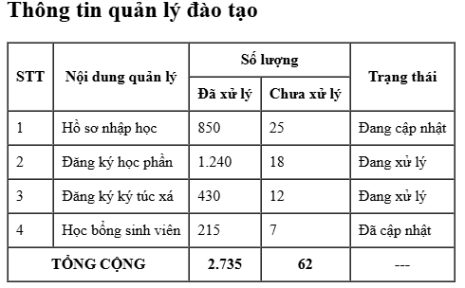

II. Forms

1. Build the Basic Form Structure
Start by creating a new HTML file:
registration.html
Use the following basic structure:
<!DOCTYPE html>
<html>
<head>
<title>Student Registration Form</title>
</head>

<body>
<h1>Student Registration Form</h1>
<form>
</form>
</body>

</html>

Practice
Open the file using Live Server and verify that the page is displayed correctly.

2. Adding a submit button
For form validation to work, there should be a button to perform the submit action. You can add a button inside the <form> element using this code:
<button>
Press this to submit form
</button>
This element, as well as all other form controls (input, select, option,…) should be put between the two tags of <form>:
<form>
Put your code here
</form>

3. Text Inputs and Basic Validation
Start with the most common form fields.

3.1. Full Name
Create a text input inside the <form> element:
<label for="name">
Full Name:
</label>

<input
type="text"
id="name"
name="fullName"
placeholder="Enter your full name"
>
Now apply validation. The name should:
- be required;
- contain at least 3 characters;
- contain no more than 50 characters.
<label for="name">
Full Name:
</label>

<input
type="text"
id="name"
name="fullName"
placeholder="Enter your full name"
minlength="3"
maxlength="50"
required
>

Practice
Test the field (by pressing Enter after typing) with:
- an empty value;
- one or two characters;
- a normal name;
- a very long value.
Observe how the browser performs the validation.

3.2. Email
Add an email field:
<label for="email">
Email:
</label>

<input
type="email"
id="email"
name="email"
placeholder="example@gmail.com"
>

Practice
Now make the field required.
After that, try to submit these following text:
- student
- student@
- student@gmail
- student@gmail.com
Observe which values are accepted by the browser.

3.3. Age
Add a numeric field for age. The student must be between 18 and 100 years old. Therefore, we add attributes min and max to check this.
<label for="age">
Age:
</label>

<input
type="number"
id="age"
name="age"
min="18"
max="100"
>
For now, to make it quicker to check validation, you can comment (gray out) the previous elements. You can do it quickly by dragging and selecting the part you want to comment.
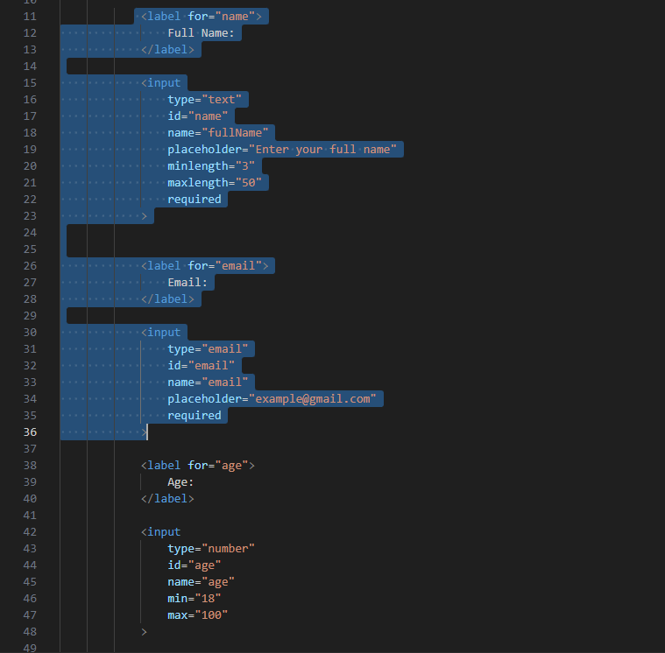
Then press this combination of button:
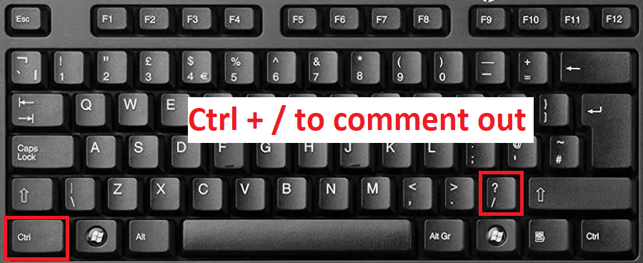
The result should look like this:
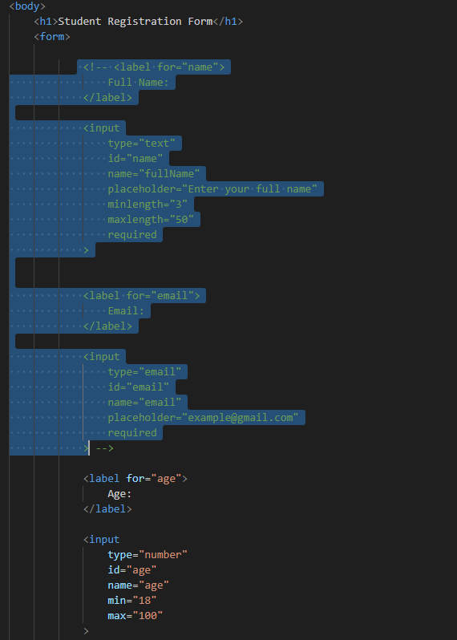
You can undo the comment by pressing Ctrl + / again on the commented section.

Practice
Input and try to submit these numbers:
- 15
- 18
- 25
- 100
- 101
There are other types of input that you can try when you have the time, simply by changing the type attribute in <input> element:
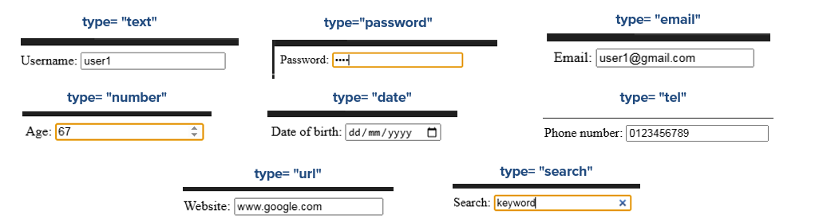

4. Radio Buttons and Checkboxes
Now continue building the same form.

4.1. Gender — Radio Buttons
A student can select one gender.
<p>Gender:</p>

<input
type="radio"
id="male"
name="gender"
value="male"
>

<label for="male">
Male
</label>

<input
type="radio"
id="female"
name="gender"
value="female"
>

<label for="female">
Female
</label>

Practice
Try selecting both options.
Then temporarily change the name attributes so that they are different:
- name="male"
- and name="female"
Try selecting both options again, observe the difference.

4.2. Hobbies — Checkboxes
A student can have multiple hobbies.
<p>Hobbies:</p>

<input
type="checkbox"
id="sports"
name="hobby"
value="sports"
>

<label for="sports">
Sports
</label>

<br>

<input
type="checkbox"
id="music"
name="hobby"
value="music"
>

<label for="music">
Music
</label>

<br>

<input
type="checkbox"
id="reading"
name="hobby"
value="reading"
>

<label for="reading">
Reading
</label>
Question
Which control should you use for each situantion? Radio button or checkbox?
- Select your major in school (from 2 majors).
- Select one of the four answers (A, B, C, D) in your test.
- Select your fluent languages (from Vietnames, English, Chinese, Japanese, Korean).

5. Select and Textarea

5.1. Major — Select
When there are too many options in your radion button, you might want to use a Dropdown list (also called a <select> element)/
Create a drop-down list:
<label for="major">
Major:
</label>

<select
id="major"
name="major"
>

<option value="">
-- Select a major --
</option>

<option value="it">
Information Technology
</option>

<option value="ai">
Artificial Intelligence
</option>

<option value="business">
Business Administration
</option>

</select>
Since the student must choose a major, add required to the <select> element:
<select
id="major"
name="major"
required
>
While there is also dropdown list for Checkbox, this cannot be done without Javascript. For now, we will ignore it, just know that it is possible!
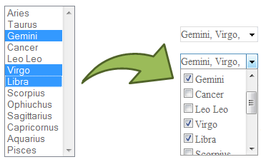

Practice
Try submitting the form without selecting a major.

5.2. Message — Textarea
Add a message field:
<label for="message">
Message:
</label>

<br>

<textarea
id="message"
name="message"
rows="5"
cols="40"
placeholder="Enter your message"
>
</textarea>
You can limit the length of message to 200 characters by using the maxlength attribute, for example:
<textarea
id="message"
name="message"
rows="5"
cols="40"
maxlength="200"
placeholder="Enter your message"
>
</textarea>

Practice
Enter a long message and observe the effect of maxlength.

6. File Input and Other Form Controls
The main form is now almost complete.

6.1. Profile Picture
Add a file input:
<label for="photo">
Profile Picture:
</label>

<input
type="file"
id="photo"
name="photo"
accept="image/*"
>
Try selecting an image. For now, we cannot do anything about it. We will learn more in Javascript section!

6.2. readonly
Create a student ID field with readonly attribute. We automatically assign a new studentID to a new student, so we don’t want the student to be able to edit this field.
<label for="studentId">
Student ID:
</label>

<input
type="text"
id="studentId"
name="studentId"
value="SV001"
readonly
>
Practice: Try editing the value in the code.

6.3. disabled
Create a country field with disabled attribute.
<label for="country">
Country:
</label>

<input
type="text"
id="country"
name="country"
value="Vietnam"
disabled
>
Practice: Try editing the value in code.
Question: What is the difference between readonly and disabled?

7. Pattern Validation
For example, we want to create a student code field that allow the student to choose their own codename, but we want to limit what the student can input, we can use the pattern attribute:
<label for="studentCode">
Student Code:
</label>

<!-- This only allow the student to enter letters and numbers, no special characters! -->
<input
type="text"
id="studentCode"
name="studentCode"
pattern="[A-Za-z0-9]+"
required
>

Practice
Test values such as:
- SV001
- ABC123
- student01
- SV-001
- SV 001
Observe the validation behavior.
Detailed regular expressions (RegEx) are outside the scope of this practical session. The goal is to understand how pattern can be used as an HTML validation rule.

8. Submit and Reset
You already have a button in your form. Without specifying the type attribute, your button will have type=”submit”.
Add another button next to your old button:
<button type="reset">
Reset Form
</button>

Practice
- Enter information into several fields.
- Click Reset.
- Enter the information again.
- Click Submit.
- Test the validation rules.

Final Challenge: Student Registration Form

Now build a complete Student Registration Form independently. Do not copy the complete form from the guided practice. Choose the appropriate HTML control and validation attributes for each requirement.

1. Requirements
Field | Requirement
Full Name | Text input; required; 3–50 characters.
Student Code | Text input; required; letters and numbers only.
Email | Email input; required.
Phone | Text input; required; use pattern validation.
Date of Birth | Date input.
Age | Number input; 18–30.
Gender | Radio buttons; select one option.
Major | Select element; required.
Year | Select element.
Hobbies | Checkboxes; allow multiple selections.
Programming Languages | Checkboxes; allow multiple selections.
Profile Picture | File input; accept image files.
Student ID | Text input; readonly; use a sample value such as SV001.
Country | Text input; disabled; use Vietnam as the value.
Address | Textarea.
Introduction | Textarea; maximum 200 characters.
Password | Password input; required.
Submit | Submit button.
Reset | Reset button.

2. Form Validation Testing
After completing the form, test it systematically.
Test | Action
Required fields | Leave required fields empty and click Submit.
Email | Try: student, student@, student@gmail, student@gmail.com.
Age | Try: 17, 18, 25, 30, 31.
Full Name | Try: A, AB, John, and a value longer than 50 characters.
Student Code | Try valid values such as SV001 and invalid values such as SV-001.
Phone | Try both valid and invalid phone numbers according to your pattern.
Major | Try submitting without selecting a major.
Reset | Enter information into several fields and click Reset.

3. Submission:
After you finish everything, show me the table from Mini Challenge and this form. Then, push your HTML files on to Github.

